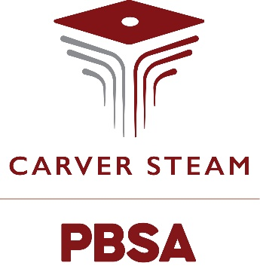

Dress Code

These are the dress code expectations for the 2024-2025 school year:
- All pants should be secured to hold the pants above the hips and undergarments should not be visible.
- Any shorts, skirts, pants with holes, etc. worn should meet the expectation of the four-inch rule, as measured at the top of the knee.
- Any jeans/pants with holes from four inches above the knee must be patched with cloth and/or not show skin. Any clothing that has excessive holes, according to the administration, will be prohibited.
- Dresses, skirts, bodysuits, etc. should not be form-fitting.
- Any spandex or opaque tights, shorts, or skirts must have a shirt or jacket that reaches the fingertip length.
- All tops must cover undergarments and have straps that are a minimum of 2 inches wide.
- All tops must be long enough to cover the midriff with an appropriate neckline.
- Hoods, hats, bonnets, bandanas, scarves, sunglasses, pajamas, loungewear, and bedroom shoes will not be worn during the school day.
- No masks or face covering are allowed during the school day.
- Any apparel that displays inappropriate language, logos, pictures (including weapons, drugs, and alcohol), gang affiliation, and advertisements is prohibited.
- Any other student attire that is deemed distracting to the learning environment by the administration is also prohibited.

